

Predictive Modeling of Credit Scores Through Logistic Regression

TCS iON Industry Project

Submitted by: Rakesh Ramavath
Dataset: UCI Credit Card Default Dataset - 30,000 records

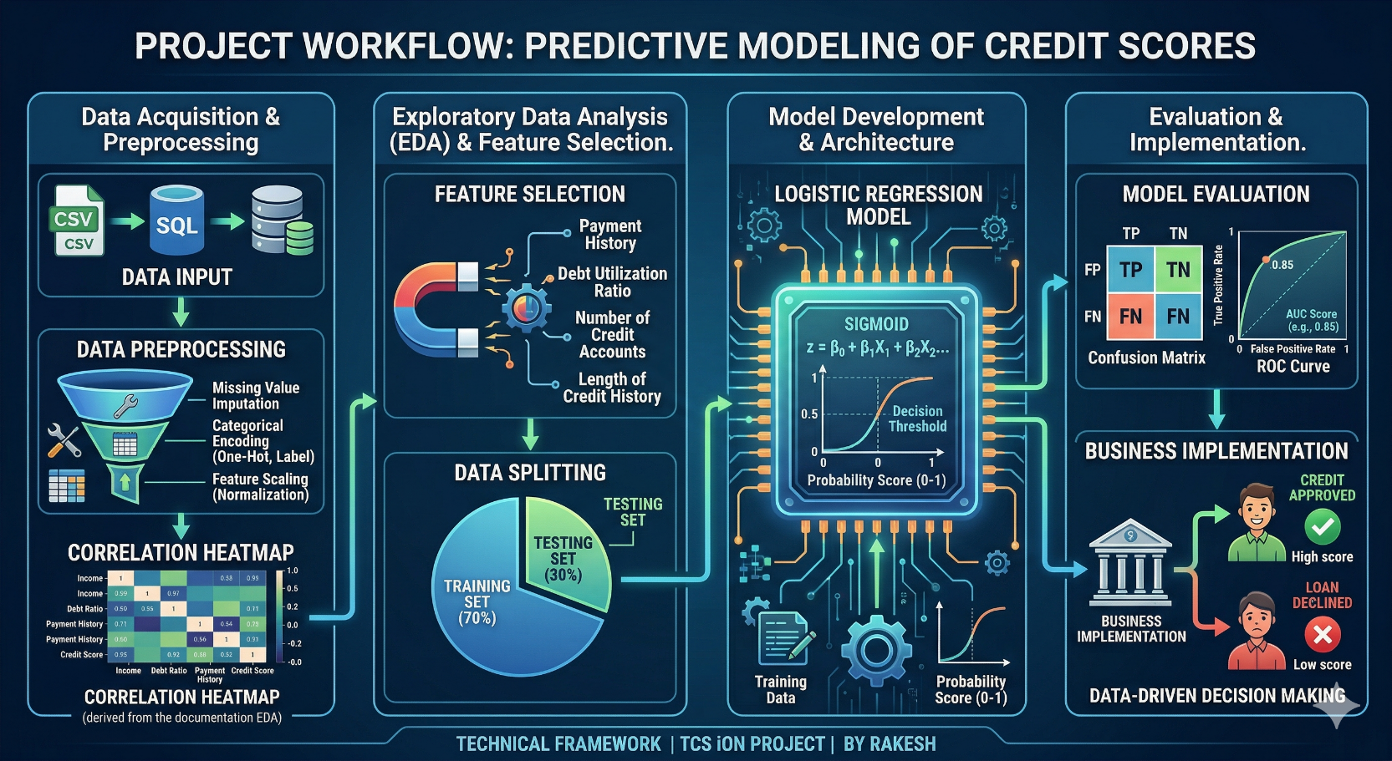

Fig: This Graphical Image maps out my end to end process this project
Table of Contents

Section | Title | Page
 | Abstract | 3
1 | Introduction  - Background  - Problem Statement  - Objective | 4
2 | Dataset Description  2.1 Dataset Source  2.2 Dataset Features  2.3 Class Distribution | 5
3 | Tools and Technologies | 6
4 | Data Preprocessing  4.1 Data Loading and Cleaning  4.2 Handling Class Imbalance  4.3 One Hot Encoding  4.4 Feature Selection  4.5 PCA  4.6 Train Test Split | 7
5 | Model Building  5.1 Pipeline  5.2 Why Logistic Regression  5.3 Hyperparameter Tuning with CrossValidator | 10
6 | Results  6.1 Model Performance  6.2 Confusion Matrix Analysis  6.3 Feature Importance  6.4 Charts and Visualizations | 12
7 | Conclusion | 17
8 | Future Improvements | 18
9 | References | 18
10 | Project Summary | 19

Abstract
This project is about predicting whether a credit card customer will default on their next payment. I worked with the UCI Credit Card Default dataset, which has 30,000 customer records from a Taiwan bank, and built a Logistic Regression model using PySpark on Google Colab.
The process started with loading the dataset using Pandas, cleaning up some bad values, and handling the fact that only 22% of customers in the data actually defaulted. I used class weights to deal with that imbalance, applied One Hot Encoding to the categorical columns, and ran PCA to reduce 16 features down to 10 components. All the preprocessing and model steps were wrapped inside a PySpark Pipeline, and I used CrossValidator to find the best hyperparameters automatically rather than guessing.
The model ended up with an AUC-ROC of 0.7321 on the test set. The biggest finding was that PAY_1 whether someone paid last month is by far the strongest signal of whether they will default next month. The project shows that a straightforward Logistic Regression model, set up carefully, can give a bank a useful, fast, and explainable credit scoring tool.



1. Introduction
1.1 Background
- Before machine learning, banks had a dedicated person for this job: the Credit Officer. Their job was to look at each loan application and decide whether the person applying was likely to pay it back. They did everything manually number of bank accounts, existing debts, how regularly someone deposited money, monthly income, family size, employment history, education level, whether they rented or owned their home, monthly expenses, marital status. The whole picture.
- When they were unsure, some officers would visit the applicant's address in person just to confirm they actually lived there. They would ask the neighbours. It was careful work, but it was slow, expensive, and it could not scale. Two different officers looking at the same application might reach two different conclusions, depending on their own experience and gut feeling.
- Credit scoring sits at the centre of financial decisions it shapes whether a loan gets approved, what interest rate gets offered, and how much risk a bank is willing to take on. With years of stored financial data now available, machine learning fits naturally into this space. A model trained on past records learns what a defaulting customer tends to look like, and it applies that same logic to every new application in seconds consistently, without fatigue, without personal bias.
1.2 Problem Statement
- The dataset used in this project has a 22% default rate, meaning 78% of customers did not default. That kind of imbalance is a real problem for machine learning a model that just predicts "no default" for everyone would look 78% accurate but would be completely useless for a bank trying to find the 22% who are at risk.
- The goal here was to build a model that could actually identify those risky customers, not just get a good accuracy number on paper. That meant handling the imbalance properly, choosing the right metric to judge performance, and making sure the model's reasoning could be explained because banks need to justify decisions to regulators and customers.
1.3 Objective
I chose Logistic Regression for this project because it fits the problem directly. It is designed for binary outcomes will this customer default, yes or no. The coefficients it produces after training tell you exactly which features pushed the prediction up and which pushed it down, so the model's reasoning is transparent. And it runs fast without needing a lot of computing power, which matters in a real banking environment where scoring needs to happen in near real time.
2. Dataset Description
2.1 Dataset Source
The dataset I used is the UCI Credit Card Default Dataset, which is freely available on the UCI Machine Learning Repository. It comes from a real bank in Taiwan and covers 30,000 credit card customers over the period April 2005 to September 2005. The target column whether each customer defaulted refers to October 2005. So the model is essentially learning to predict next month's default based on the previous six months of behaviour.
2.2 Dataset Features
The original file has 25 columns. The first one is just an ID number from 1 to 30,000 it carries no information about default risk, so I dropped it. That left 24 columns: 23 input features and 1 target. The features group into four categories as shown below.

LIMIT_BAL | Credit Information | Credit limit in NT dollars
SEX, EDUCATION, MARRIAGE, AGE | Demographics | Customer personal details
PAY_1 to PAY_6 | Payment Status | Monthly repayment status for 6 months
BILL_AMT1 to BILL_AMT6 | Bill Amounts | Monthly bill statement amounts
PAY_AMT1 to PAY_AMT6 | Payment Amounts | Amount paid by customer each month
label | Target | 0 = no default, 1 = defaulted

2.3 Class Distribution
Out of the 30,000 customers, 23,364 did not default and 6,636 did. That is a 77.88% to 22.12% split. This imbalance was one of the first things I had to think about a model that just learned to say "no default" on almost every prediction would look about 78% accurate but would miss all the actual defaulters. I dealt with this by calculating class weights before training, which I explain in Section 4.2.

3. Tools and Technologies Used
Before writing any code, I read through the project roadmap to understand what tools would be needed from start to finish. I imported all the required libraries at the top of the notebook in one go that is standard Python practice, and it also helped my evaluator see at a glance everything the project depended on.
Below is each tool I used and what I used it for:
- Google Colab: I ran the entire project inside Google Colab, which is a free online Python notebook that runs in the browser. No installation needed. I uploaded my dataset file directly to the Colab session from my computer.
- Python 3.12: The programming language everything is written in.
- PySpark 4.0.2: PySpark is the Python API for Apache Spark. I used it to process the 30,000 records and to build, tune, and evaluate the model. Colab does not come with PySpark pre-installed, so I ran !pip install pyspark at the start of every session.
- Pandas: PySpark cannot read .xls files directly, so I used Pandas to load the Excel dataset first. Once it was loaded as a Pandas dataframe, I converted it to a PySpark dataframe for the rest of the work.
- Numpy: Used for numerical calculations mainly to compute the sigmoid function values for the visualisation.
- Matplotlib: I used Matplotlib to create the bar charts, including the class distribution chart and the ROC curve.
- Seaborn: I used Seaborn for the correlation heatmap and the confusion matrix chart it handles those better than raw Matplotlib.
- Scikit-learn: I used Scikit-learn's roc_curve and confusion_matrix functions for the evaluation step. PySpark gives you the AUC score but not the full ROC curve data points.
- Datetime: I imported Datetime to generate a timestamp when saving the model, so each saved version has a unique name. This is standard practice in industry for version control.
- VectorAssembler: This is a PySpark feature tool. LogisticRegression in PySpark does not accept individual columns it needs all features combined into one vector column. VectorAssembler does that job.

- StandardScaler: I used StandardScaler to normalise all feature values. LIMIT_BAL can go up to one million while AGE is around 20 to 80 without scaling, the large numbers would dominate and the small ones would barely register. StandardScaler brings everything to a mean of 0 and standard deviation of 1.
- OneHotEncoder: I used OneHotEncoder to handle the categorical columns. EDUCATION, MARRIAGE, and SEX should not be treated as numeric rankings, so I converted them into binary vectors instead.
- PCA: Principal Component Analysis. I used it to reduce 16 features down to 10 components while keeping 83.99% of the information. This was part of the project roadmap requirement for dimensionality reduction.
- Pipeline: A PySpark ML Pipeline chains multiple steps together in this project: VectorAssembler, StandardScaler, and LogisticRegression. Using a Pipeline means all three steps happen in the correct order automatically every time, whether during training or during hyperparameter tuning.
- LogisticRegression: The main model. I created a LogisticRegression instance inside the Pipeline, set the featuresCol, labelCol, and weightCol, and let CrossValidator handle the fitting.
- CrossValidator + ParamGridBuilder: Instead of guessing hyperparameter values, I used CrossValidator to test 6 combinations of regParam and maxIter automatically using 5-fold cross validation. It picks the best combination based on AUC-ROC.
- BinaryClassificationEvaluator: Used to calculate the AUC-ROC score the primary metric for this project.
- MulticlassClassificationEvaluator: Used to calculate Accuracy, Precision, Recall, and F1 Score after the best model was selected.

4. Data Preprocessing
Data preprocessing was the most time consuming part of the project. The model is only as good as the data going into it, so I spent a lot of time on this before writing a single line of model code. I will walk through each step in the order I did it.
4.1 Data Loading and Cleaning
- The dataset came as a .xls Excel file. PySpark cannot read Excel files directly, so the first thing I did was use Pandas to load it with pd.read_excel(). One thing I noticed straight away was that row 0 in the file is just a description line it says something like "this is a dataset of credit card clients" not actual column headers. The real column names are in row 1. So I used header =1 to skip that description row and read the column names from row 1 instead. After that the dataset came in clean: 30,000 rows and 25 columns, exactly matching what the UCI repository described.
- The next step was renaming two columns before anything else. The target column was called "default payment next month" it has spaces in the name, which causes problems in PySpark, and also PySpark's LogisticRegression specifically expects the target column to be named "label". So I renamed it. I also renamed PAY_0 to PAY_1, because the UCI dataset has a known naming mistake where the first repayment status month is called PAY_0 instead of PAY_1.
- After renaming I dropped the ID column. It is just a serial number from 1 to 30,000 and has absolutely no relationship with whether someone defaults. Keeping it would have confused the model, so I removed it immediately. At this point the dataset had 24 columns.
- Then I looked at the categorical columns more carefully. According to the UCI data dictionary, EDUCATION should only contain the values 1(graduate school), 2(university), 3(high school), or 4(others). But the actual data also had 0, 5, and 6 sitting in there, none of which are explained anywhere in the documentation. I grouped all three undocumented values into category 4(others). MARRIAGE had the same issue it should only be 1(married), 2(single), or 3(others), but had 0 in the data too. I mapped 0 to 3 for the same reason.
- Finally I ran a null value check across every column to make sure there was no missing data. Every column came back as zero nulls. The dataset was completely clean no imputation or missing value handling was needed at all, which made things simpler.
4.2 Handling Class Imbalance
With the data clean, the next problem to deal with was the class imbalance. Out of 30,000 customers, 23,364 did not default and 6,636 did a roughly 78% to 22% split. This is a real issue. If I just fed this data into a model without doing anything about it, the model would quickly learn that predicting "no default" almost every time gives a high accuracy score. It would ignore the minority class entirely. For a bank, that is the worst possible outcome they need to catch the defaulters, not be congratulated for mostly getting the majority right.
To fix this I calculated class weights using the formula: weight = total records / (number of classes x count of that class). For the no-default class this came out to 0.642, and for the default class it came out to 2.2604. I then added a new column called classWeight to the PySpark dataframe so that each row carried its weight into the training process. This told the model to pay 2.26 times more attention to defaulter records than non-defaulter records, pushing it to actually learn the minority pattern rather than ignoring it.
4.3 One Hot Encoding
The next step was handling the categorical columns properly. EDUCATION, MARRIAGE, and SEX are stored as numbers like 1, 2, 3, but these numbers do not have any meaningful order or ranking. EDUCATION=1 is not "less than" EDUCATION=3 they are just different categories. If I fed them into the model as plain integers, the model would treat them as if 3 was mathematically larger than 1, which would give wrong results.
I used PySpark's OneHotEncoder to convert all three columns into binary vector columns instead. Each category becomes its own yes/no column. I also set dropLast=True, which removes the last category from each encoded column. This is important because if you keep all categories, one of them is always perfectly predictable from the others that is called the dummy variable trap, and it causes problems with the coefficients.Dropping the last category avoids it.
After encoding, the three original columns became three new vector columns named EDUCATION_ohe, MARRIAGE_ohe, and SEX_ohe, which were then used in the feature selection step.
4.4 Feature Selection
- With all columns cleaned and encoded, I checked how much each feature actually correlated with the target (label) column. I used PySpark's stat.corr() function to calculate this for every numeric feature. The results were sorted by absolute correlation value so I could see which features mattered most.
- PAY_1 came out on top with a correlation of 0.3248. That makes intuitive sense if someone did not pay last month, they are probably in financial trouble and likely to miss next month too. PAY_2 through PAY_6 also had decent correlations ranging from 0.19 to 0.26. LIMIT_BAL had a negative correlation of -0.1535, meaning higher credit limits tend to go with lower default risk again, makes sense, as banks give higher limits to more reliable customers.
- At the bottom of the list were BILL_AMT1 through BILL_AMT6 and AGE, all with correlations below 0.02. These features were adding noise without contributing useful signal, so I set a threshold of 0.02 and dropped anything below it. This brought the numeric feature count from 23 down to 13, which combined with the 3 encoded categorical columns gave 16 features going into the model.
4.5 PCA (Principal Component Analysis)
- With 16 features selected, I applied PCA as the next dimensionality reduction step. PCA works by finding the directions in the data that carry the most variation called principal components and expressing the original features as a combination of these new directions. It lets you keep most of the information while using fewer numbers to represent it.
- I used PySpark's PCA class and set k=10, keeping 10 components from the 16 features. I had to first assemble the features into a vector column and scale them before applying PCA, since PCA is sensitive to scale. After fitting, I checked the explained variance for each component. The first component explained 24.04% of the variance on its own. Together, the 10 components explained 83.99% of the total variance meaning only about 16% of the information was lost in the reduction, which is acceptable.
4.6 Train Test Split
- Before building the pipeline and training anything, I split the data into training and test sets. I used an 80/20 split 24,126 rows for training and 5,874 for testing which is within the 75-80% training range specified in the project roadmap.
- The reason I did the split before building the pipeline is important, if I had scaled all the data first and then split, the StandardScaler would have used information from the test rows when calculating means and standard deviations. That is called data leakage the test set would no longer be truly unseen. By splitting first, the scaler only ever touches the training rows, and the test set stays completely isolated until the final evaluation.
- I also used seed=42 when calling randomSplit(), which fixes the random number generator so the same split comes out every time the code runs. Without a seed, different runs would give different splits and make results hard to reproduce.

5. Model Building

With the data properly prepared, I moved on to building the model. Rather than running each step manually in sequence, I structured everything around a PySpark Pipeline, which kept the workflow clean and made hyperparameter tuning much easier.

5.1 Pipeline
A PySpark Pipeline takes a list of stages and runs them in order every time you call fit() or transform(). I set up three stages for this project.
Stage 1: was VectorAssembler, which takes the 16 selected feature columns and combines them into a single vector column called features_raw. PySpark's LogisticRegression will only accept a vector column as input, so this step is not optional.
Stage 2: was StandardScaler, which reads features_raw and outputs a normalised features column. This is the column the model actually trains on.
Stage 3: was LogisticRegression, set up with featuresCol="features", labelCol="label", and weightCol="classWeight" so it would use the class weights I calculated earlier.
The advantage of using a Pipeline is that when CrossValidator runs its 30 training cycles, the VectorAssembler and StandardScaler run fresh each time on the training fold only — the scaler never sees test fold data during any of the cross validation rounds. This is the correct way to avoid data leakage inside cross validation.
5.2 Why Logistic Regression
- Logistic Regression takes the weighted sum of all input features each feature multiplied by its coefficient and feeds that number through the sigmoid function. The sigmoid formula is sigmoid(z) = 1 / (1 + e^-z). Whatever number you put in, the sigmoid converts it to a value between 0 and 1. That output is the predicted probability of default. If it is above 0.5, the model labels the customer as likely to default. Below 0.5, it predicts no default.
- I chose Logistic Regression for this project for three specific reasons. First, default prediction is a binary problem a customer either defaults or does not and Logistic Regression is built exactly for that. Second, the coefficients it produces after training are interpretable. You can look at the coefficient for PAY_1 and immediately know that a higher value there means more risk something a bank analyst can actually explain to a customer or a regulator. Third, it is fast and light on resources, which matters for a system that needs to score thousands of applications quickly.
5.3 Hyperparameter Tuning with CrossValidator
- Once the Pipeline was set up, I used PySpark's CrossValidator with ParamGridBuilder to find the best hyperparameters. The two hyperparameters I tuned were regParam, which controls regularisation (how much the model is penalised for having large coefficients), and maxIter, which controls how many training iterations the model runs.
- I built a grid with three values for regParam (0.01, 0.1, and 0.5) and two values for maxIter (10 and 20). That gave 6 combinations in total. CrossValidator then tested each combination using 5-fold cross validation it splits the training data into 5 equal parts, trains on 4 of them, and evaluates on the remaining 1. It repeats this 5 times so every part gets used as the evaluation set once. With 6 combinations and 5 folds each, the total number of training runs was 30.
- The metric I used for selection was AUC-ROC, set via BinaryClassificationEvaluator. After all 30 runs, CrossValidator automatically identified the best combination. The winner was regParam=0.01 and maxIter=10 the lowest regularisation and the fewer iterations. That best pipeline was then applied to the held out test set for final evaluation.
6. Results
After training finished, I ran the best model against the 5,874 test records it had never seen during training. The evaluation used five metrics to get a full picture of how the model was performing.
6.1 Model Performance

Metric | Score | What it means
AUC-ROC | 0.7321 | Primary metric separates defaulters from non-defaulters
Accuracy | 0.6825 | Overall correct predictions
Precision | 0.7666 | Of predicted defaults, how many were real
Recall | 0.6825 | Of actual defaults, how many were caught
F1 Score | 0.7069 | Balance between precision and recall

- The AUC-ROC of 0.7321 is the headline number for this project. It measures how well the model distinguishes defaulters from non-defaulters across all possible decision thresholds. A score of 0.5 means the model is no better than random guessing. A score of 1.0 would be perfect. Getting 0.73 on a real financial dataset with genuine class imbalance is a reasonable result.
- The accuracy of 0.6825 is lower than you might expect, and that is actually a sign the model is working correctly. By applying class weights, I pushed the model to stop leaning toward the majority class. An earlier version of the model without class weights had 81% accuracy but missed nearly 1,000 defaulters. The current model catches far more defaulters at the cost of some overall accuracy which is the right trade-off for a bank.

6.2 Confusion Matrix Analysis
The confusion matrix breaks down exactly what the model got right and wrong on the 5,874 test records.
Category | Count | What it means
True Negatives (TN) | 3,145 | Did not default model correctly predicted no default
False Positives (FP) | 1,426 | Did not default but model predicted they would (false alarm)
False Negatives (FN) | 439 | Actually defaulted model missed them (costly for bank)
True Positives (TP) | 864 | Actually defaulted model correctly caught them

The 439 false negatives are the most important number here. These are customers who actually defaulted but the model missed them. In a real bank, each one of those is a loan that goes bad without warning. Reducing this number further without triggering too many false alarms (the 1,426 false positives) is the core challenge of credit scoring, and it is where more sophisticated models or richer data would help. The model correctly caught 864 actual defaulters a default detection rate of 66.31%, meaning it caught about 2 in every 3.
6.3 Feature Importance
One of the main reasons I chose Logistic Regression is that the coefficients it produces after training tell you directly how much each feature matters and in which direction. A positive coefficient means that feature increases the probability of default; a negative coefficient means it decreases it. The larger the absolute value, the stronger the effect.

Feature | Coefficient | Direction | What it means
PAY_1 | 0.5053 | Increases risk | Strongest predictor missed last payment = high risk
MARRIAGE_ohe | 0.1359 | Increases risk | Marriage status has some effect
SEX_ohe | 0.1084 | Increases risk | Gender has a small effect
PAY_2 | 0.0928 | Increases risk | Two months ago payment delay matters too
PAY_3 | 0.0914 | Increases risk | Three months ago payment delay
PAY_AMT2 | -0.1655 | Decreases risk | Paying more last month = safer customer
PAY_AMT1 | -0.1632 | Decreases risk | Paying more two months ago = safer
LIMIT_BAL | -0.1218 | Decreases risk | Higher credit limit = lower risk
PAY_AMT3 | -0.1039 | Decreases risk | Payment amount 3 months ago
EDUCATION_ohe | 0 | No effect | Education level had zero measurable impact

PAY_1 stands out completely its coefficient of 0.5053 is more than three times larger than the next highest feature. If a customer missed last month's payment, that single fact dominates the prediction. The PAY_AMT features (how much was actually paid each month) all came out negative, which makes sense customers who pay more are less risky. LIMIT_BAL being negative also makes sense banks give higher credit limits to more trustworthy customers. The most surprising result was EDUCATION_ohe at 0.0000, meaning after encoding, education level had zero measurable influence on default probability in this dataset.
6.4 Charts and Visualizations
Six charts were generated during the project. They are shown below in the order they appear in the analysis.
Chart 1 Class Distribution: The imbalance between 23,364 non-defaulters and 6,636 defaulters that made class weighting necessary.
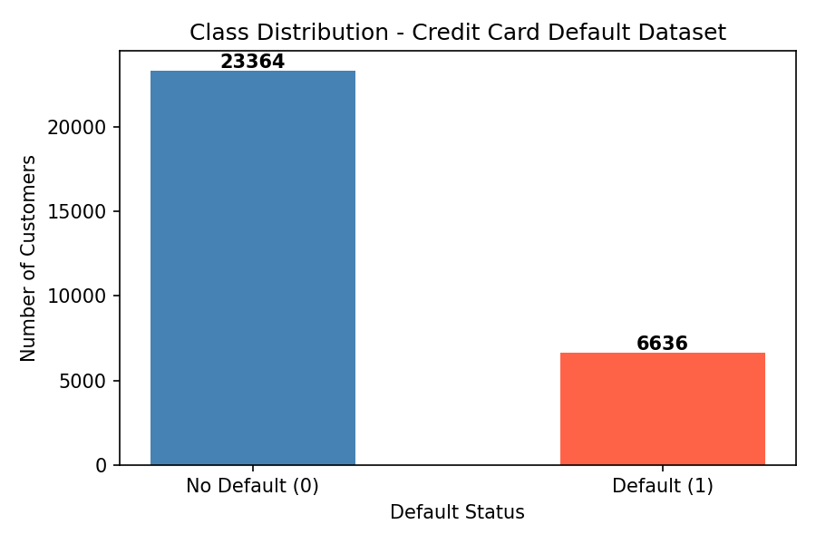

Chart 2 Feature Correlation Heatmap: PAY_1 through PAY_6 show the darkest red in the label row, confirming they are the strongest predictors. The dense red block in the BILL_AMT columns shows heavy multicollinearity between those features one reason they were dropped.
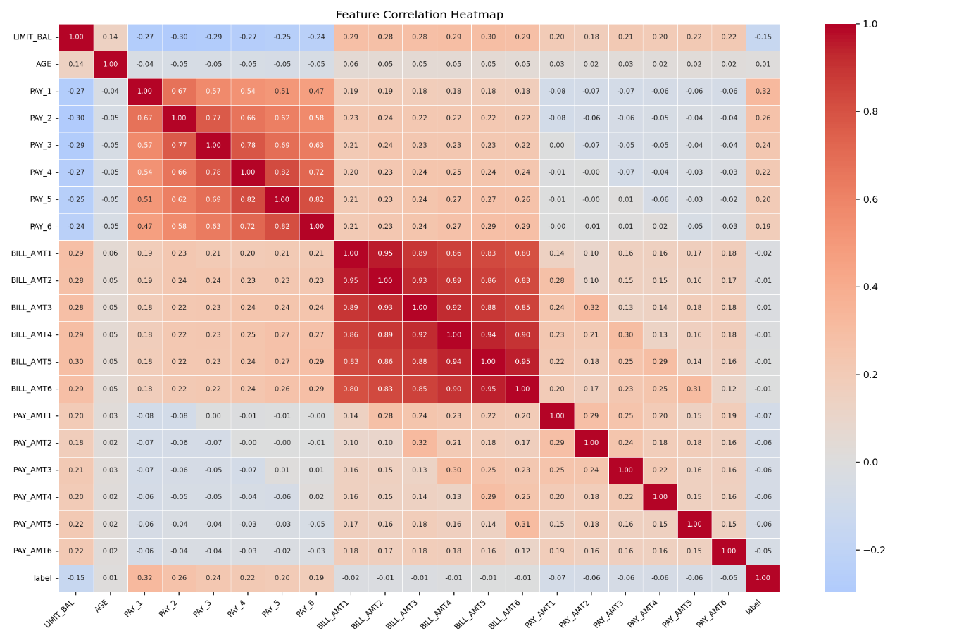
Chart 3 Sigmoid Function (Illustrative): How Logistic Regression converts any input number into a probability between 0 and 1. The red dashed line at 0.5 is the decision boundary above it the model predicts default, below it predicts no default.
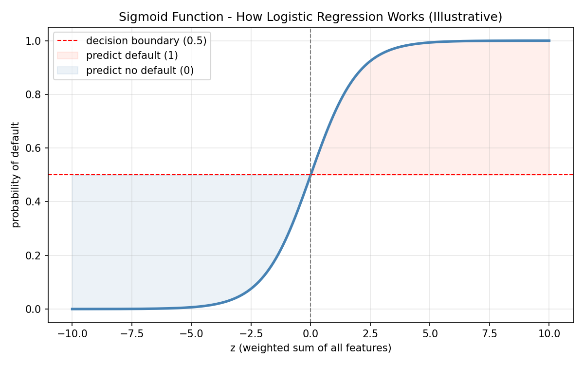
Chart 4 ROC Curve: The red curve shows model performance at every possible decision threshold. AUC = 0.7321. The further the red curve bends toward the top left corner above the gray diagonal (random guessing at AUC = 0.5), the better.
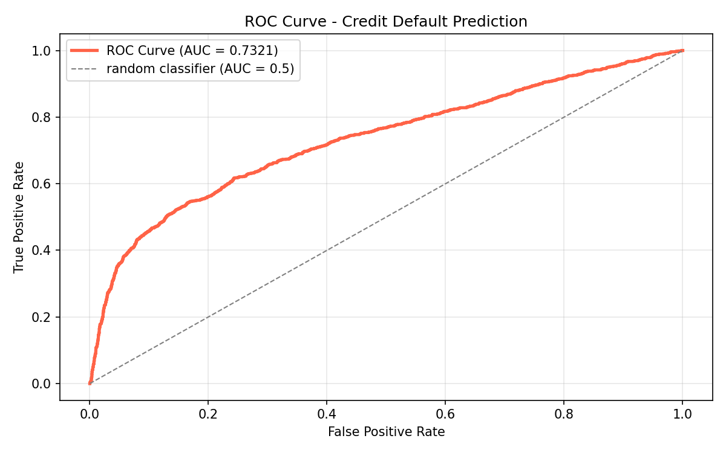
Chart 5 Confusion Matrix: Visual breakdown of correct and incorrect predictions. Dark blue = True Negatives (3,145). Light areas = errors (FP: 1,426 | FN: 439). Bottom right = True Positives (864).
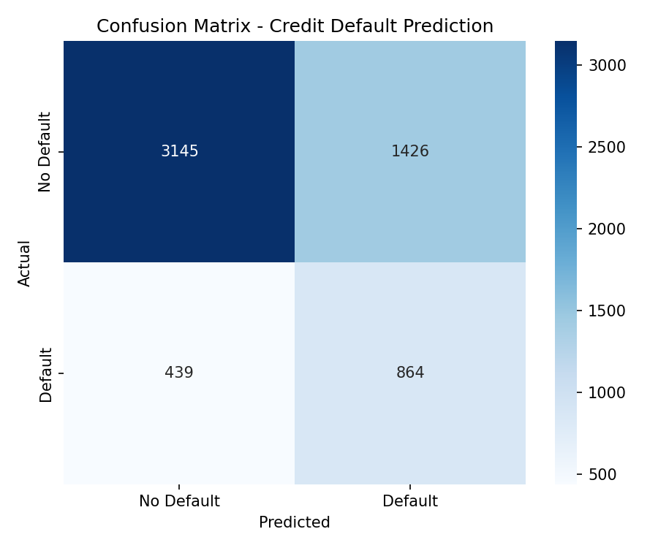

Chart 6 Feature Coefficients: Red bars increase default risk, blue bars decrease it. PAY_1's red bar dwarfs everything else. PAY_AMT2 and PAY_AMT1 have the longest blue bars paying more = lower risk.
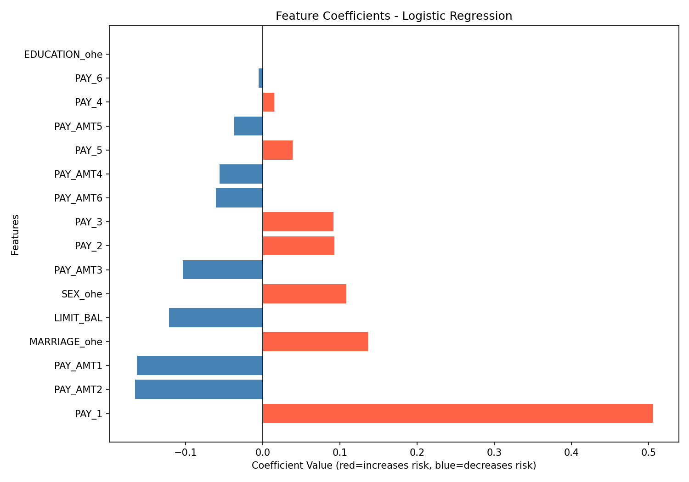
7. Conclusion
- This project built a credit default prediction model using Logistic Regression in PySpark, trained on 30,000 customer records from a Taiwan bank. The full workflow covered loading and cleaning the data, handling class imbalance with weights, encoding categorical variables, selecting features by correlation threshold, applying PCA, splitting the data correctly to avoid leakage, building a Pipeline, tuning hyperparameters with CrossValidator, and evaluating the results across five metrics.
- The model achieved an AUC-ROC of 0.7321 on the test set a reasonable result for a real financial dataset. The clearest and most useful finding from the project is that PAY_1 (last month's repayment status) is by far the strongest predictor of default, with a coefficient of 0.5053. If a customer missed last month's payment, the model flags them strongly. How much a customer pays each month (PAY_AMT1, PAY_AMT2) also matters more payment means less risk. Credit limit has a negative relationship, meaning higher-limit customers tend to be more reliable. Education level, after proper encoding, had no measurable effect at all.
- The honest limitation is the 439 missed defaulters customers who defaulted but the model did not catch. A bank loses money on each one. This model is a useful starting point but is not a complete solution on its own. Catching more defaulters without overwhelming the bank with false alarms would require either a more powerful algorithm or richer input data, or both.
8. Future Improvements

- Try other algorithms. Random Forest or Gradient Boosting would likely catch more defaulters on this dataset since they handle non-linear patterns and class imbalance better than Logistic Regression.
- Apply SMOTE (Synthetic Minority Oversampling Technique) instead of just using class weights. SMOTE creates synthetic examples of the minority class, giving the model more defaulter patterns to learn from rather than just upweighting the ones that exist.
- Collect more data. This dataset covers 6 months from one bank in Taiwan in 2005. A model trained across multiple banks, time periods, and geographies would generalise far better to real current customers.
- Build a web interface using Streamlit or Flask. A simple form where a bank employee enters customer details and gets a risk prediction in real time would make this model actually usable in a production environment without any coding knowledge.
- Set up periodic retraining. Customer behaviour changes — especially during economic downturns. A model trained only on 2005 data will degrade over time. Scheduling regular retraining on new data would keep the predictions reliable.

9. References

1. UCI Machine Learning Repository Default of Credit Card Clients Dataset: https://archive.ics.uci.edu/ml/datasets/default+of+credit+card+clients
2. Apache Spark MLlib Documentation: https://spark.apache.org/docs/latest/ml-guide.html
3. Python Official Documentation: https://www.python.org/
4. Pandas Documentation: https://pandas.pydata.org/
5. Matplotlib Documentation: https://matplotlib.org/
6. Seaborn Documentation: https://seaborn.pydata.org/
7. Scikit-learn Documentation: https://scikit-learn.org/
8.CreditAnalysisEvalutaion: https://youtube.com/playlist?list=PLMmVziys3riDR7v0KQYHy U--uzxNEtltn&si=3I2Rgg7ImXIy3-vW

10. Project Summary

Item | Detail
Student | Rakesh Ramavath
Project | TCS iON Industry Project — Credit Score Prediction
Dataset | UCI Credit Card Default Dataset (30,000 records)
Algorithm | Logistic Regression (PySpark MLlib)
Environment | Google Colab (PySpark 4.0.2, Python 3.12)
Train / Test Split | 80% training (24,126 rows) / 20% testing (5,874 rows)
AUC-ROC | 0.7321
Accuracy | 0.6825
Precision | 0.7666
Recall | 0.6825
F1 Score | 0.7069
Best regParam | 0.01
Best maxIter | 10
Features Selected | 16 (after correlation threshold filtering)
PCA Components | 10 (83.99% of variance retained)
Strongest Predictor | PAY_1 — coefficient 0.5053
Milestones Completed | 3 of 3

